**Lesson Twenty-Six:**

**The Resurrection, Appearances, and Ascension of Jesus**

**The Resurrection of Jesus**

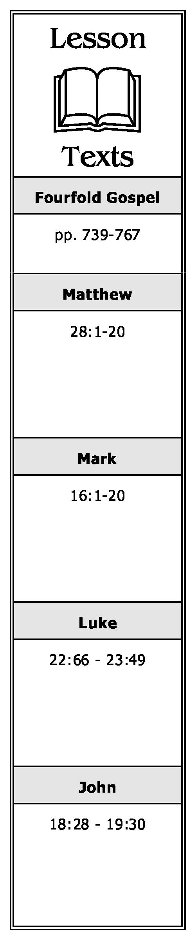

**(Matthew 28:1-8; Mark 16:1-8; Luke 24:1-8,12; John 20:1-10)**

1. Why did the women come to the tomb of Jesus? What did they see when they arrived there?
2. Who spoke to the women? What were they told had happened? What were they told to do?

**The First and Second Appearances of the Risen Christ**

**(Matthew 28:9-10; Mark 16:9-11; Luke 24:9-11; John 20:11-18)**

1. To whom did Jesus first appear after His resurrection? Describe this meeting.
2. To whom did Jesus make His second appearance after the resurrection? Describe this meeting.

**The Report of the Guards to the Jewish Rulers (Matthew 28:11-15)**

1. Who advised the chief priests as what had happened with the body of Jesus? What was their response?

**The Third and Fourth Appearances of Jesus   
(Mark 16:12-13; Luke 24:13-35; 1 Cor. 15:5)**

1. To whom did Jesus make His third appearance after His resurrection?
2. Describe the fourth post-resurrection appearance of Jesus which took place on the road to Emmaus.

**The Fifth Appearance of Jesus (Mark 16:14; Luke 24:36-43; John 20:19-25)**

1. What time and day was it when Jesus appeared to His disciples? What did He do when He appeared to them? What evidence did He present to prove He was the risen Christ?
2. Which of the twelve was not present? What was his reaction when told they had seen Jesus?

**A Chronological Study of the Life of Jesus Gene Taylor 67**

**The Sixth Appearance of Jesus (John 20:26-31; 1 Corinthians 15:5)**

10. How much time had elapsed since the previous appearance of Jesus?

11. Briefly summarize this appearance especially noting the reaction of Thomas.

12. Why did the apostle John say he wrote of these events?

**The Seventh Appearance of Jesus (John 21:1-25)**

13. Where did this appearance take place? Which of the disciples were there? Why were they there?

14. Briefly describe this appearance.

15. Briefly summarize the exchange between Jesus and Peter? What was the purpose of this exchange?

**The Eighth Appearance of Jesus (Matthew 28:16-17; 1 Corinthians 15:6)**

16. Briefly describe this appearance of Jesus.

**The Great Commission Given (Matthew 28:18-20; Mark 16:15-18; Luke 24:46-47)**

17. Briefly summarize the “great commission” and its terms as recorded in:

1. Matthew.
2. Mark.
3. Luke.

**The Ninth and Tenth Appearances of Jesus (Luke 24:44-49; Acts 1:3-8; 1 Corinthians 15:7)**

18. Where did Jesus tell His disciples to stay until they received power after the Holy Spirit came upon them?

19. After receiving power, where were the disciples to be witnesses of the risen Christ?

**The Ascension (Mark 16:19-20; Luke 24:50-53; Acts 1:9-12)**

20. Where did the ascension take place? Who witnessed it? Briefly describe it.

21. Who appeared to the disciples as they viewed the ascension? What was their message?

**A Chronological Study of the Life of Jesus Gene Taylor 68**